How Do I Find My Partner Draw Summary in Worldox?
- Click on the shortcut button at the top of the Worldox screen for “Users” to search in your Users profile (this profile is unique to you and only contains documents for you.

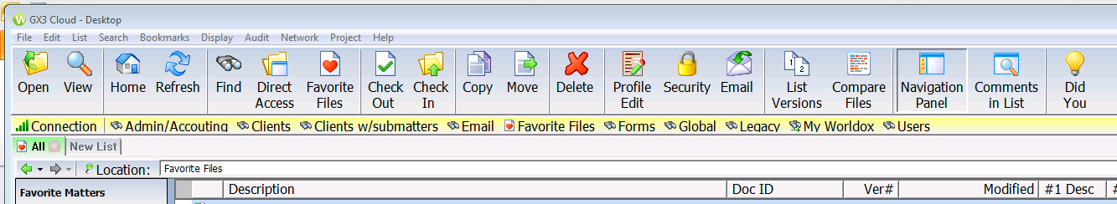

- The search box will pop-up and will default to selecting your user profile. You will just type in “draw” into the “Name/Comment” search box (1st one) like the image below and hit the “Search” button:

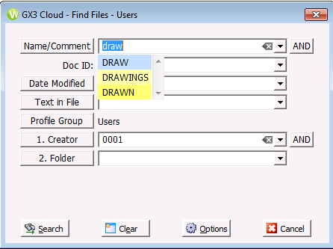

- This will bring up a listing of all documents with the word “Draw” in it that are listed in your user profile, so you can easily find your partner draw summaries.

- Once you have opened just one of your draw summaries, that folder for your draw summaries will now show up in your Favorite Matters root directory on the left panel of Worldox at the very bottom like this, so you can just double click on the folder “Partnership Draws” and it will automatically open all your draw summaries in the main search listing on the right:
